**Attending Skills Contract**

**STEP 1:** Students will type 5 sentences about how they personally can use each attending skill to form good habits. **Please include the words ‘Northglenn Knight(s)’ in each sentence.

**Attending Skills** (one sentence each)**:**

* Be in the Moment
* Appropriate Body Language
* Appropriate Eye Contact
* Appropriate Feedback
* Questions to Clarify or Validate

**Pick at least one of the following words to use for each sentence:** (each connector is a possible choice)

* Success or successful
* Positive
* Participate
* Kind or kindness
* Happy
* Win or winning
* Goal
* Learn or learning
* Achieve or achievement
* Commit or commitment

**STEP 2** Put all of the sentences together to form a paragraph. Block Style (no indenting!)

**STEP 3** Using the Home Ribbon, apply the following formatting:

1. 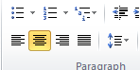Add **Attending Skills** as a title
2. 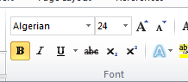Center it
3. Change title font to Algerian, 24, & Bold.
4. Change the font of the *paragraph* to Comic Sans MS, 14, & Purple
5. 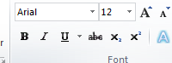Change the font of every attending skill to **Charlemagne STD, 18 & Navy Blue**.
6. Change the font of the word Knights to be Superscript & 18
7. Each of the suggested words (from the right side) will be a different
   * Font
   * Size
   * Color

from the rest of the text.

1. Add a signature line (on the insert ribbon).



1. Print it
2. Sign it
3. Turn in the completed paper