**Home Ribbon Workout**

**Directions:**

1. **Type your name in the header where it says “Type your Name Here.”** *If you double click on the grey area, it will let you in there to type. Double click back in the document to get BACK to the main part of the document.*
2. **Choose File Save As** *(Press F12 key to easily get to the ‘save as’)***: YourLastNameHomeRibbonGPD in your H drive in your computer_apps folder.**
3. **Follow all directions for EVERY section.**
4. **Have FUN!**

**Type in the definition for some great HABITS – in your OWN WORDS:**

|  |
| --- |
| * Collaboration means * An example of Collaboration is like when |
| * Compassion means * An example of Compassion is like when |
| * Courage means * An example of Courage is like when |
| * Integrity means * An example of Integrity is like when |
| * Perseverance means * An example of Perseverance is like when |
| * Responsibility means * An example of Responsibility is like when |

**Now, using the Font section of the Home Row Ribbon:**

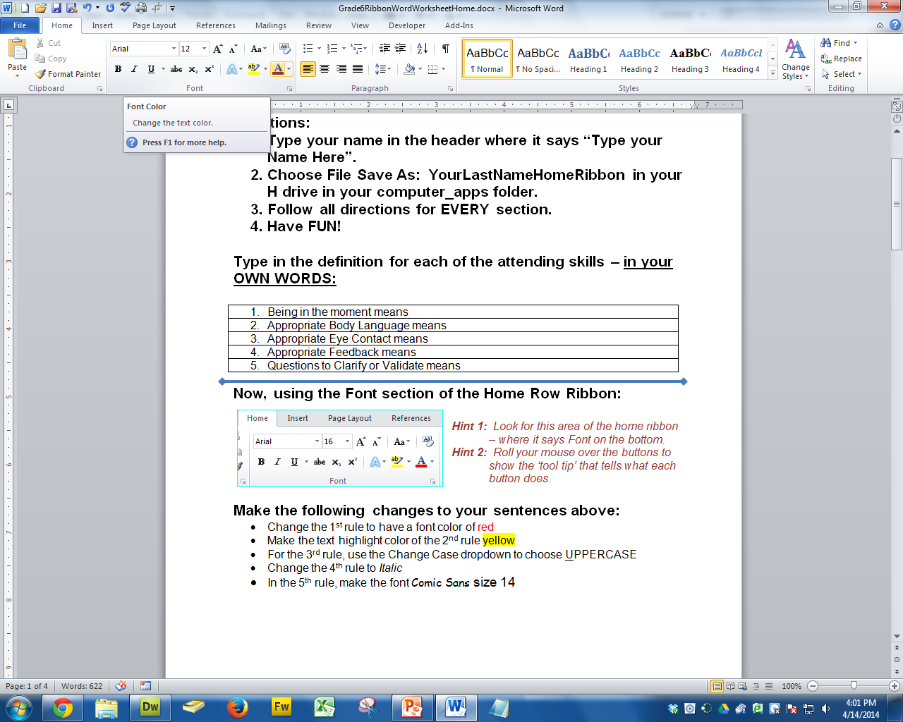

***Hint 1:*** *Look for this area of the home ribbon   
 – where it says* **Font** *on the bottom.*

***Hint 2:*** *Roll your mouse over the buttons to   
 show the ‘tool tip’ that tells what each   
 button does.*

This one shows the tool tip for **Font Color** when I   
 roll over it and wait a second.

**Make the following changes to your sentences about the Habits of a Learner that you completed on the previous page:**

1. Change the 1st Habit [**Collaboration**…] to have a font color of red
2. Make the text highlight color of the 2nd Habit of **Compassion** yellow
3. (This one is hard to find – use the tooltips to help you!) For the 3rd habit of **Courage**,

* use the **Change Case** dropdown
* to choose **UPPERCASE** while the sentence is highlighted

1. Change the 4th habit of **Integrity** to ***I****talic to slant the text of the rule.*(Hint: it is NOT a font and it starts with an ‘I’)
2. In the 5th habit of Perseverance, change the **Font** to Courier New   
   and the **Font size** to 14.
3. For the 6th habit of Responsibility, add a text effect of SHADOW.  
   Hint: Text Effects and Typography,  
   Choose Shadow

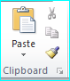

**Using the Clipboard section of the Home Ribbon:**

Highlight and copy the instructions in **Make the following . . .** and paste them at the top of the next page using ‘Keep Text Only” (the clipboard that has an **A** on it) under Paste.

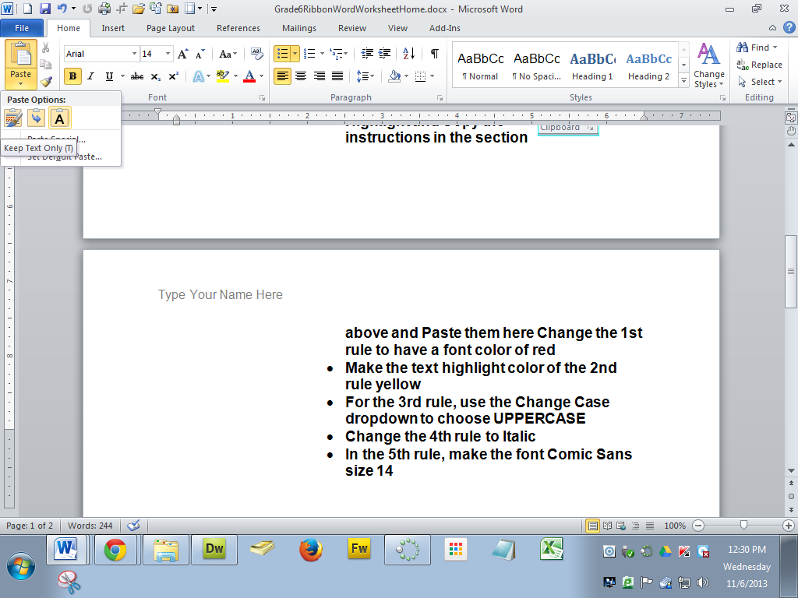

***Hint 3: You will need to click on the triangle under the Paste to show the***Keep Text Only

**Paste them here:**

**Now, using the Paragraph section of the Home Ribbon make the following changes to the description of National Veterans day from Wikipedia:**

|  |
| --- |
| National Veterans Day  Veterans Day is an official United States holiday which honors people who have served in armed service also known as veterans. It is a federal holiday that is observed on November 11. It coincides with other holidays such as Armistice Day and Remembrance Day, which are celebrated in other parts of the world and also mark the anniversary of the end of World War I. (Major hostilities of World War I were formally ended at the 11th hour of the 11th day of the 11th month of 1918, when the Armistice with Germany went into effect.)  Veterans Day is not to be confused with Memorial Day; Veterans Day celebrates the service of all U.S. military veterans, while Memorial Day is a day of remembering the men and women who died while serving. |

* Center the title inside the table

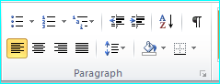

* Using the Shading Tool, color the first paragraph light grey.
* Using the Line and Paragraph Spacing tool, make the 2nd paragraph line spacing 1.5

**Using the Styles Section of the Home Row Ribbon make the following changes to the definition of Random Acts of Kindness that Google shows us:**

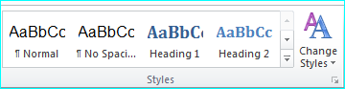

* Choose a style of “Title” for the heading words (first line)
* For the words **Web definitions** “Subtitle”
* For the definition sentence: “Quote”
* For the web address: “Intense Reference”

Random Acts of Kindness (first line)

Web definitions (Subtitle)

A random act of kindness is a selfless act performed by a person or people wishing to either assist or cheer up an individual person or people. ... (Quote)

<http://en.wikipedia.org/wiki/Random_acts_of_kindness> (use Intense Reference)